**For the exp no : 4**

**1.**

Now, we have to create a /user/root/ file, since hadoop works with this defined structure

**hdfs dfs -mkdir -p /user/root**

We can verify if it was created correctly

**hdfs dfs -ls /user/**

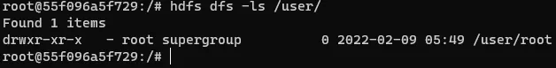

First, move these from where you downloaded them and put them in the cloned repository folder. Then type the next command (you have to be in your normal terminal, not inside the namenode container, you can use “exit” command).

**docker cp <given exp jar file path> namenode:/tmp**

**Example : docker cp hadoop-mapreduce-examples-2.7.1-sources.jar namenode:/tmp**

Do the same for the .txt file

**docker cp <given exp input file path> namenode:/tmp**

**Example : docker cp el_quijote.txt namenode:/tmp**

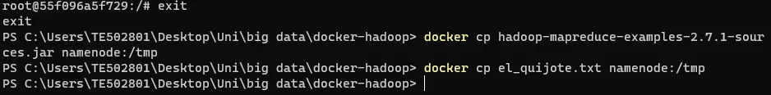

Get in the namenode container again

**docker exec -it namenode bash**

Then

**hdfs dfs -mkdir /user/root/input**

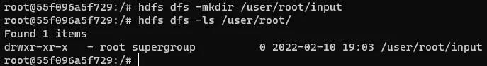

**Firts cd to /tmp (cd /tmp)**

**hdfs dfs -put el_quijote.txt /user/root/input**

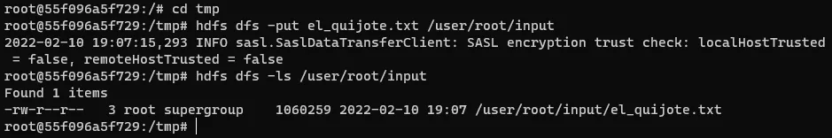

**hadoop jar hadoop-mapreduce-examples-2.7.1-sources.jar org.apache.hadoop.examples.WordCount <inputpath> <outputpath> “sample given in above image”.**

You’ll see a large input, but if you have done the past steps right everything should be fine.

**See the result :**

**hdfs dfs -cat /user/root/output/\***

**Convert result to txt file and stored to the local computer:**

**hdfs dfs -cat /user/root/output/part-r-00000 > /tmp/quijote_wc.txt**

**exit**

**docker cp namenode:/tmp/quijote_wc.txt .**